  
FEST Research Group

Final Year Project Proposal

|  |  |
| --- | --- |
| **Project Title:** | KIDSTUBE |
| **Degree Program/ Title:** | Computer Science |

|  |  |  |  |
| --- | --- | --- | --- |
| Project Supervisor: |  | Signature: |  |
| Project co-supervisor: |  | Signature: |  |

|  |  |  |
| --- | --- | --- |
| Student Name & Registration No: | Email & Phone Number: | Student Signature: |
| Misbah Aslam Sheikh 28272 | [misbah.asl96@gmail.com](mailto:misbah.asl96@gmail.com) 03009210111 |  |
| Muneeb Ahmed 28863 | [muneebahmed39@yahoo.com](mailto:muneebahmed39@yahoo.com) 03022220672 |  |
| Anosha Ilyas 32356 | [saadilyas49@gmail.com](mailto:saadilyas49@gmail.com) 03312087744 |  |

**TABLE OF CONTENT**

|  |  |  |  |  |
| --- | --- | --- | --- | --- |
| 1 |  |  | Introduction/Abstract | 3 |
| 2 |  |  | Purpose | 3 |
| 3 |  |  | Scope | 3 |
| 4 |  |  | Overall Description | 4 |
|  | 4.1 |  | Problem Description | 4 |
|  | 4.2 |  | Product Objective | 4 |
| 5 |  |  | Feasibility Study | 5 |
|  | 5.1 |  | Statement of Constraints | 5 |
|  | 5.2 |  | Identification of System Objectives | 5 |
|  | 5.3 |  | Description of Outputs | 5 |
|  | 5.4 |  | Feasibility Considerations | 5 |
|  |  | 5.4.1 | Legal Feasibility | 5 |
|  |  | 5.4.2 | Operational Feasibility | 6 |
|  |  | 5.4.3 | Economic Feasibility | 7 |
|  |  | 5.4.4 | Technical Feasibility | 8 |
| 6 |  |  | Functional Requirements | 8 |
| 7 |  |  | Nonfunctional Requirements | 19 |
| 8 |  |  | Model Analysis | 10 |
|  | 8.1 |  | Block Diagram | 10 |
|  | 8.2 |  | Use Case Diagram | 11 |

1. **Introduction/Abstract**  
   In today’s world everyone is using smartphones and apps even small children’s uses apps like YouTube to watch funny videos and cartoons. YouTube has created a special app for kids known as YouTube Kids where there is content for small kids like cartoons and videos but the flaw in this app is that anybody can sign up and upload videos which may be irrelevant or not good for child to watch and there are multiple advertisements which is irrelevant to children and there is no time limit option for parents. In our project we will create such an app for children in which these all flaws will be covered and we will also add other features like if a child is viewing a cartoon for 2 hours he must have to watch some religious or ethical videos and there will be no advertisements which are irrelevant to children.

Our prime objective is to create a platform where children can enjoy videos which are relevant and good for them and which will also help in their right growth since there is religious and ethical content as well in assistance with parents.

1. **Purpose:**  
   The purpose of this project is to provide a particular platform in which a child of below 7 age can easily spend their time watching certain things on the app without parents’ guide. This document will specify the feasibility study to the requirements analysis of the project with particular flow model in order to make things understandable.
2. **Scope:**  
   The scope of this project defines the fulfillments of parents need and to satisfy them with such a thing on which they can blindly trust and let their children depend upon it for such activities than YouTube without having any advertisement, or any other act that parents won’t like for their child.

*Our goal is to provide or made the replica of the product with certain amendments that’s requires  
*Voice search option  
*Time limit of watching any video  
*No comments  
*No personal information is collected  
*Block video or channel  
*No user is allowed to sign up or upload the video(decision can be changed)  
*Only the owner has the right to upload and delete the content by the reviews of the people on app store  
*All types of youngest interest will be tried to update in the application based on our culture  
*Cartooned characters, educational videos we will enforce Islamic videos too that includes the recitation of Qaida to Quran Paak including duas and naat  
*Whole day planning schedule would be set as default  
*Time limit will be applied manually by the user(parent)  
*No promotion of irrelevant advertisement's on the app

1. **Overall Description:**  
   This section will give an overview of the whole system. The system will be explained in its context to show how the system interacts with other systems and introduce the basic functionality of it. It will also describe the type of stakeholders that will use the system and the functionality is available for each one of them.

4.1 **Problems Description:**

The system we decided to made come out because of the following drawbacks:

**\***[YouTube](https://www.youtube.com/)**is public, so, anyone can see the videos that you post, anyone can post a video, there could be copyright infringement issues, and there could be issues of privacy invasion.**

**\*If the children can access**[YouTube](https://www.youtube.com/)**, you probably need a parental block, some videos can sometimes be inappropriate without warning, there is violence on some of the videos, there are explicit videos and the teens are recording violence to post on**

*For particular children need YouTube has created special app for the youngest fans that offers particular dilemma according to respective needs but this also has certain things that is not preferred by our country policy.

4.2 **Project Objective:**

Develop an app considering the needs of a child and preferment of the parent according to our culture and environment needs without having any advertisement of adds in the app.

1. **Feasibility Study:**

A feasibility study is conducted to select the best system that meets the performance requirements. This entails an identification description, an evaluation of candidate systems, and the selection of the best system for the job. Three key considerations are involved in feasibility analysis: economic, technical and behavioral.

We have conducted feasibility study for our project so that we can know wheather the project on which we want to work on is feasible technically, operationally, economically, legally or not.

* 1. **Statement Of Constraints:**

Constraints are factors that limit the solution of a problem. Some constraints which are identified in this project during the initial investigation are as follow:

*No irrelevant promotions on the applications

*No one is allowed to upload a video except the owner

*Videos which are good for children's of age 7 or less will be uploaded

5.2 **Identification Of System Objectives:**

Once the constraints are spelled out. The analyst proceeds to identify the system’s specific performance objectives. They are derived from the general objectives specified in the project directive at the end of the initial investigation. The steps are to state the system’s benefits and then translate them into measurable objectives.

Our objective is to build such an application which will help the children to watch the cartoons & videos which are good for their minds and parents remain worry free.

5.3 **Description Of Outputs:**

A final step in system performance definition in describing the output required by the user. An actual sketch of the formal and contents of the reports as well as a specification of the media used their frequency, size and numbers of copies required are prepared at this point.

5.4 **Feasibility Considerations:**

5.4.1 **Legal Feasibility:**

Determines whether the proposed system conflicts with the legal requirements, approval of the senior’s assistants and clients of the project and university policies in order to meet the legal requirements of the project that wouldn’t harm any association or leading requirement/character in the project.

We will use all the tools required for the development of the app & other relevant for this project which are freely available or we will buy it to avoid any legality in near future. We will upload videos in this app such that their arises no copyright infringement issues.s

5.4.2 **Operational Feasibility:**

We have a team that has knowledge of application & software development so there may not arise any problem regarding this in near future. This application will be designed solely for children's so there will be the videos and content that is of children's interest or benefit so this app will proved to be very beneficial for parents who remain concerned about what their child is watching on internet, so it will be a very useful system. This will be promoted well by the team so that it becomes acceptable by the people and they use this application for their children's benefit & fun under their control & it will be very easy and secure to use even for a person who does not have much technological knowledge.

There exists an app like this made by YouTube named as YouTube kids but there are certain flaws in the apps which will be resolved by us in our application.

Process: Throughout the development of the app we will take suggestions from different people about improvements which may help to redesign it in a better way and we analyze those suggestions if they are proved to be beneficial we will work on it.

Evaluation**:** This application will be beneficial for all stakeholders. This app may be a threat for the existing YouTube kids app (If become popular) because it overcomes the flaws in YouTube kids app. The threat for this app is that we may counter problems while uploading videos on the app due to copyright infringement

Implementation:We have almost all the resources needed to go forward with this project that is human resources, financial resources & technical resources.

Resistance: Many people are resistant to use any new app because they think that app might use their data wrongly or this app may incur negative impact on the device & minds of users. To counter this we will promote in such a way that it is used by peoples efficiently and without any doubt.

5.4.3 **Economical Feasibility:**

The purpose of the economic feasibility assessment is to determine the positive economic benefits to the organization that the proposed system will provide. It includes quantification and identification of all the benefits expected. This assessment typically involves a cost/benefits analysis.

We have done a cost estimation for our project to get to know that are project is feasible economically which is as follow

**Cost Estimation**

|  |  |  |  |  |
| --- | --- | --- | --- | --- |
| **Serial No** | **Resources** | **Unit Cost** | **Quantity** | **Total Cost** |
| 01 | Senior Front hand  developer(GUI) | 25000 | 01 | 25000 |
| 02 | Junior Front hand  developer(GUI) | 15000 | 01 | 15000 |
| 03 | Backhand developer | 40000 | 01 | 40000 |
| 04 | Junior Backhand developer | 20000 | 01 | 2000 |
| 05 | Designer | 15000 | 01 | 15000 |
| 06 | Database Developer | 20000 | 02 | 40000 |
| 07 | Software Quality Tester | 12000 | 03 | 36000 |
| 08 | Project Manager | 45000 | 01 | 45000 |
| 09 | Software Promotion | 50000 (depends upon the market rate) | 01 | 50000 |
| 10 | Hardware (laptop+soft) | 50,000 | 01 | 50,000 |

We will hire whole team for this project so there salary will be included in cost of the budget. The above table display the cost that is required to complete this project i.e. Rs 336000

5.4.4 **Technical Feasibility:**

Compatibility: The technology (i.e. the framework) which has to be use is compatible/supportable to run on any device with latest updates or user end.  
Upgradeability: The system is to be developed and design in such a manner that it will be viable to upgrade the system in future with ease.  
Technical capacity/skills: The skills required to develop this system exist locally within our team however if the project require more assistance as per clients need it can be managed.  
Hardware: We do have the required hardware requirements to run the software which are needed for app development and database. Moreover from the user side, there are no advance hardware requirements because this is an android application so it’s only required an active internet connection and an android phone.  
Upgradeable Project: The software used and database requirements are viable for this project and can be altered in future if required. The framework technology and the layout design which is used in this project is feasible to manage in future and are considered technically upgradeable and our team is capable to future assistance. Methodologies, techniques and skills required for support assistance are feasible and the project can be done technically.

1. **Functional Requirements**  
   1. Sign up/Login:  
    Parent is allowed to sign up the app by entering their date of birth and email to verify the registrations.  
   2. Search Option:  
    Search option will be created in order to find the user’s desired thing.  
   3. Create Playlist:  
    Parents have the option to create playlist of their own and lock the screen so child won’t be able to search any content or video without parent’s permission.  
   4. Timeout:  
    Feature of Timeout will also be provided in order to make child not fully dependent upon the phone/ YouTube. After a certain interval of time the app will automatically close for estimated time.  
   5. Advertisement/Uploading:  
    No user is allowed to upload the video and no comments will be allowed to post, with that any sort of advertisement during the playlist or opening the app won’t be promoted either it is paid or unpaid.  
   6. Blocking:  
    Parent may also block the certain videos that bother them to let be watched by their child.  
   7. Resuming:  
    When the interval of time limit finishes the app will be resumed to playlist of default page or to the parents playlist until and unless it is unlocked.
2. **Nonfunctional Requirements**  
   1. Availability:   
    This application will be available on play store and app store for users to install and use it. It should be available to use 24/7 for users (except for the time of maintenance of app).2. Modifiable:   
    This application will be modifiable according to the changing needs and requirements of potential user  
   3. Scalability:   
    This application shall be expandable to accommodate the increase in no of users.  
   4. Secure:  
    The app will be secure enough as no user is supposed any sort of this until the feature is introduced in the app.  
   5. Portability:  
    The app will be accessed in every android system having the good internet connection.
3. **Model Analysis**

8.1 **Block Diagram**

According to user’s aspect

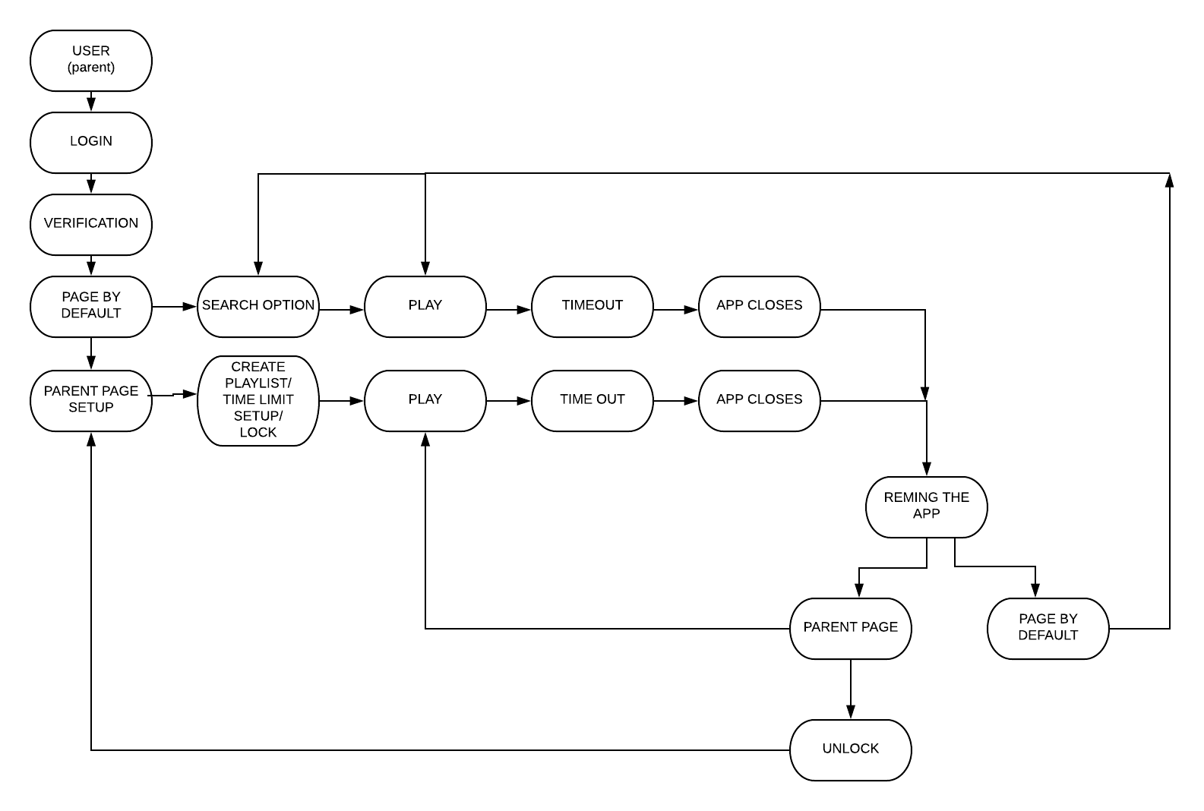

Actual product/model/application may be differ from the initialization.

8.2 **Use Case Diagram**

